|  |
| --- |
| Department of Software Engineering  Mehran University of Engineering and Technology, Jamshoro |

|  |  |  |  |
| --- | --- | --- | --- |
| SWE411 – SOFTWARE DESIGN AND ARCHITECTURE | | | |
| Instructor | Mr. Arsalan Aftab Memon | **Practical/Lab No.** | 04 |
| Date |  | **CLOs** | 3 |
| Signature |  | **Assessment Score** | 0.4 Marks |

|  |  |
| --- | --- |
| Topic |  |
| Objectives | * State Transition Diagram |

|  |
| --- |
| Lab Discussion: Theoretical concepts and Procedural steps |

**Tool: - STAR UML**

**Theory:**

**State Transition Diagram**

It describes different states of a component in a system. The states are specific to a component/object of a system. The system receives events from the outside world, and each event can cause the system to transit from one state to another. As Statechart diagram defines states it is used to model lifetime of an object.

**Purpose**

The most important purpose of Statechart diagram is to model life time of an object from creation to termination.

* + To model dynamic aspect of a system.
  + To model life time of a reactive system.
  + To describe different states of an object during its life time.
  + Define a state machine to model states of an object.

**State diagrams are used:**

*to describe the behavior of a system.*

Specifically a state diagram describes the *behavior of a single object in response to a series of events in a system.*

**Basic State Diagram Symbols and Notations**

1. **States:**

States *represent situations* during the life of an object.

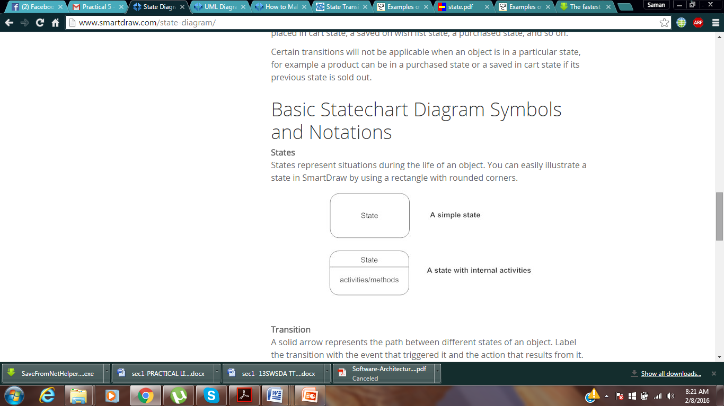

**2. Transitions:**

A solid arrow *represents the path between different states of an object.*  Label the transition with the event that triggered it and the action that results from it.

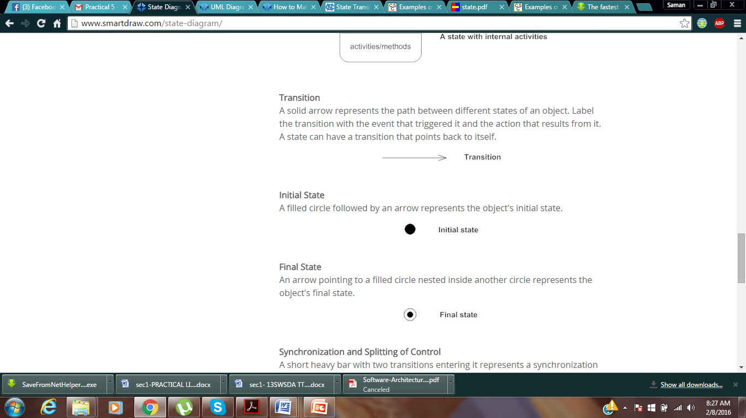

**3. Initial state:**

A filled circle followed by an arrow *represents the object's initial state.*

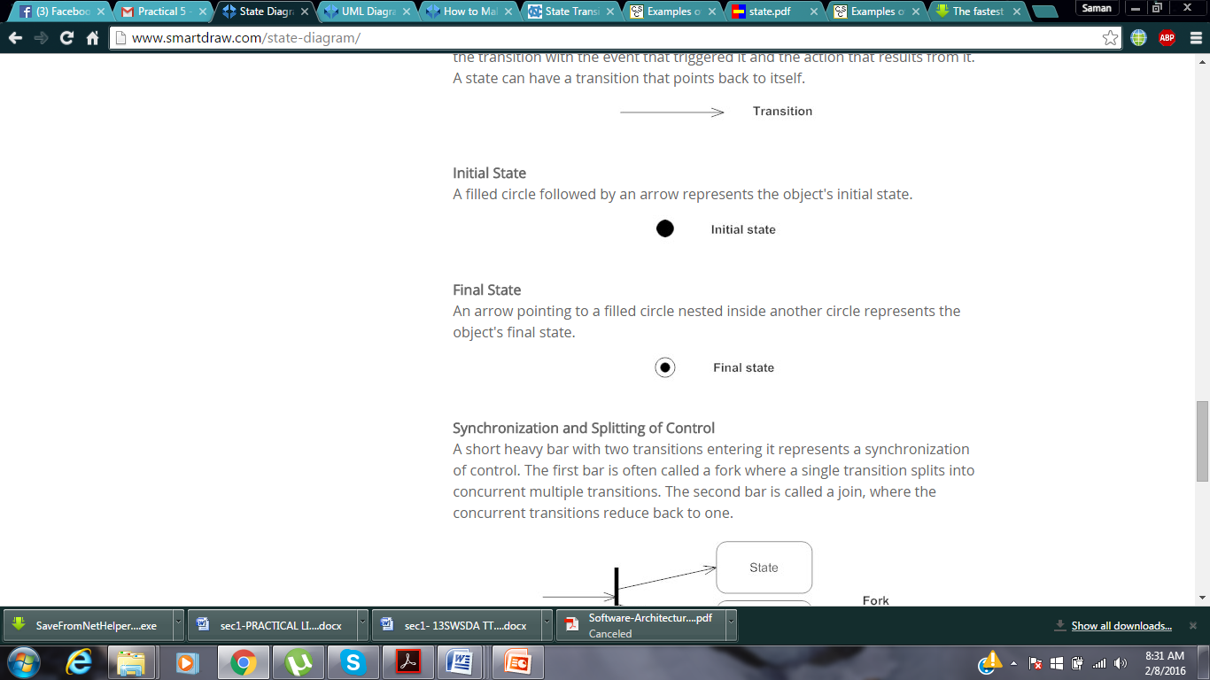

4. **Final state:**

An arrow pointing to a filled circle nested inside another circle ***represents the object's final state.***

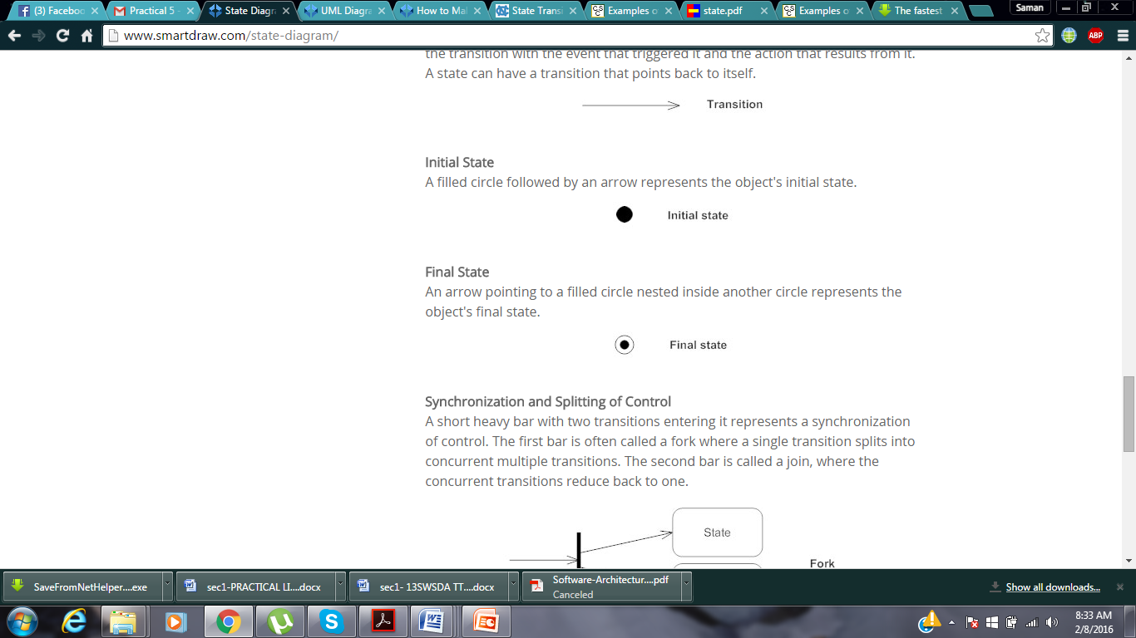

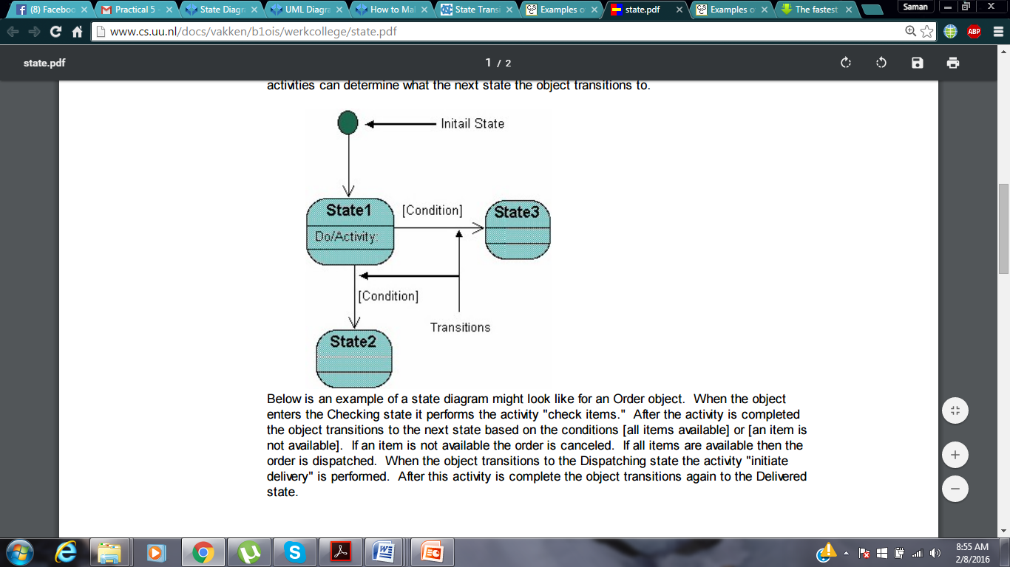

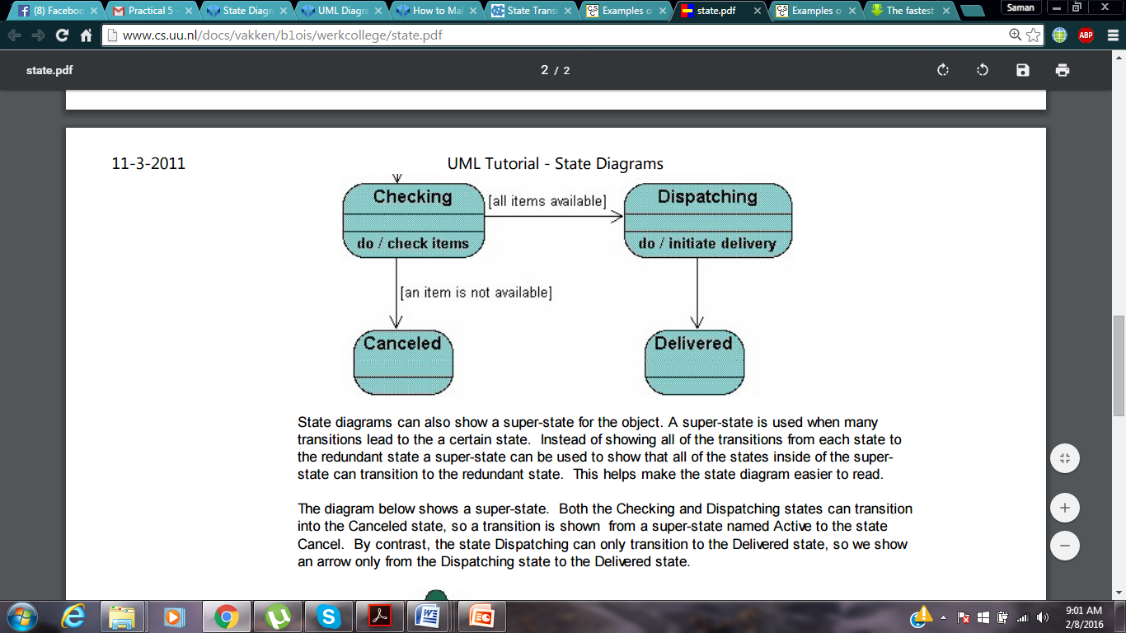

* The following is an example of a Statechart diagram where the state of *an* object is analyzed.

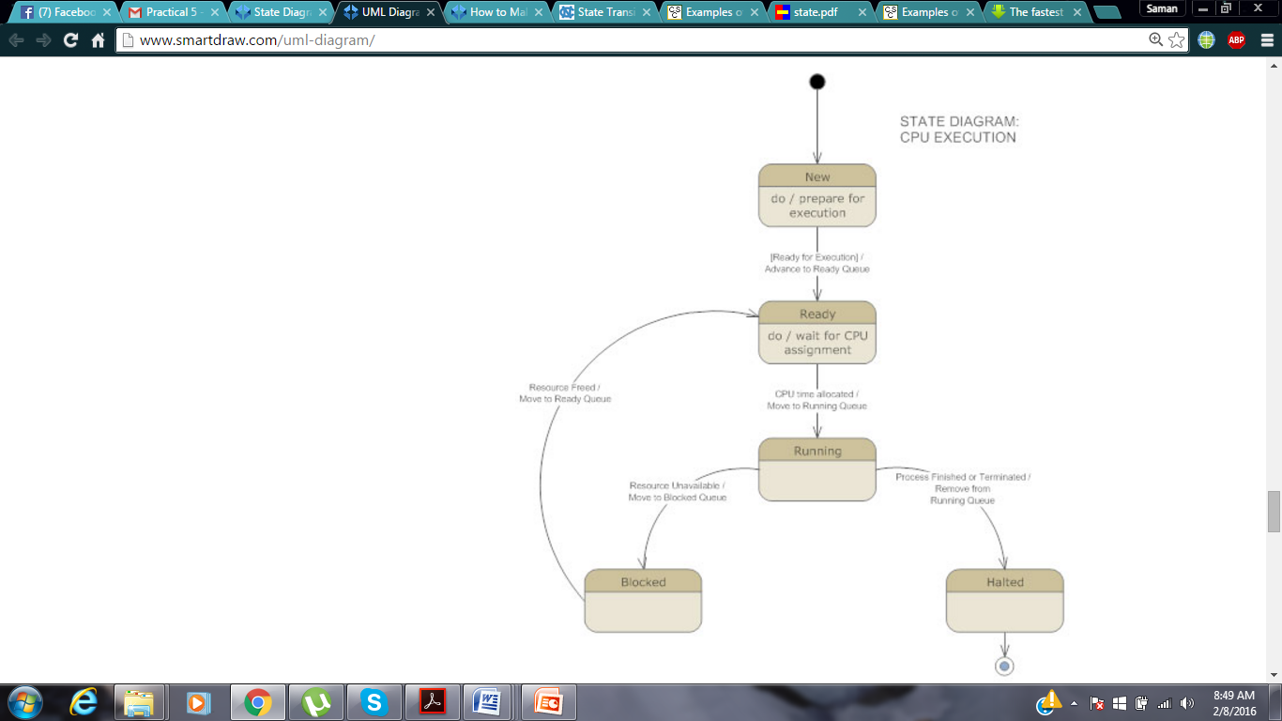

TASK:

* Create a state Transition diagram of:
  + **Flight reservation**
  + **ATM process**